**Mobile testing**

**“TODO” application**

**Functionality**

TODO application is implemented as single screen software.

At the top of the screen is displayed the user's greeting and current date.

The user can change the language of the interface using a button "Change locale".

List of available languages: English, Spanish, Polish, Romanian, Russian, Ukrainian.

The interface language should follow language in the device settings.

The user can add tasks by clicking on the "Add task" button.

The task addition form contains 2 fields ("Task name" - mandatory to fill in,

"Task description" - no mandatory), 3 possible colors (green, blue, pink) and 2 buttons ("Cancel", "Add").

By clicking on "Add", a new task is added under the task's creation date and is displayed on the screen. The task can be deleted by clicking on it and confirming the deletion by clicking on the "Delete" button.

The application supports changing the orientation screen.

Bug 1

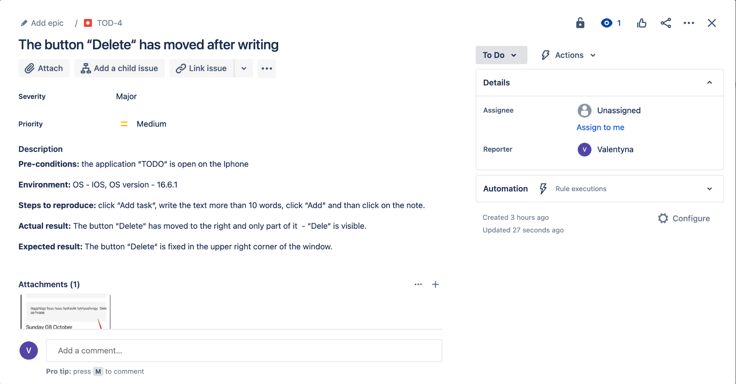

Attachments

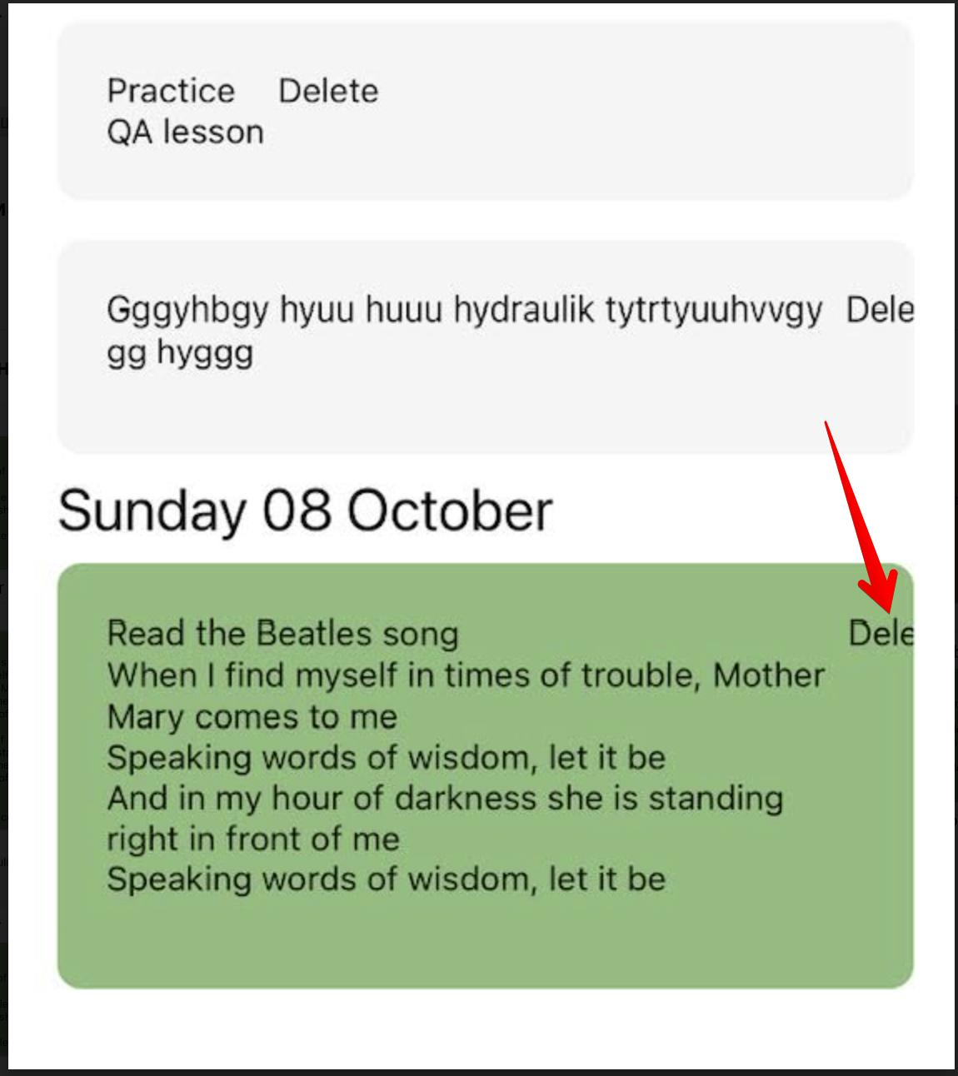

Bug2

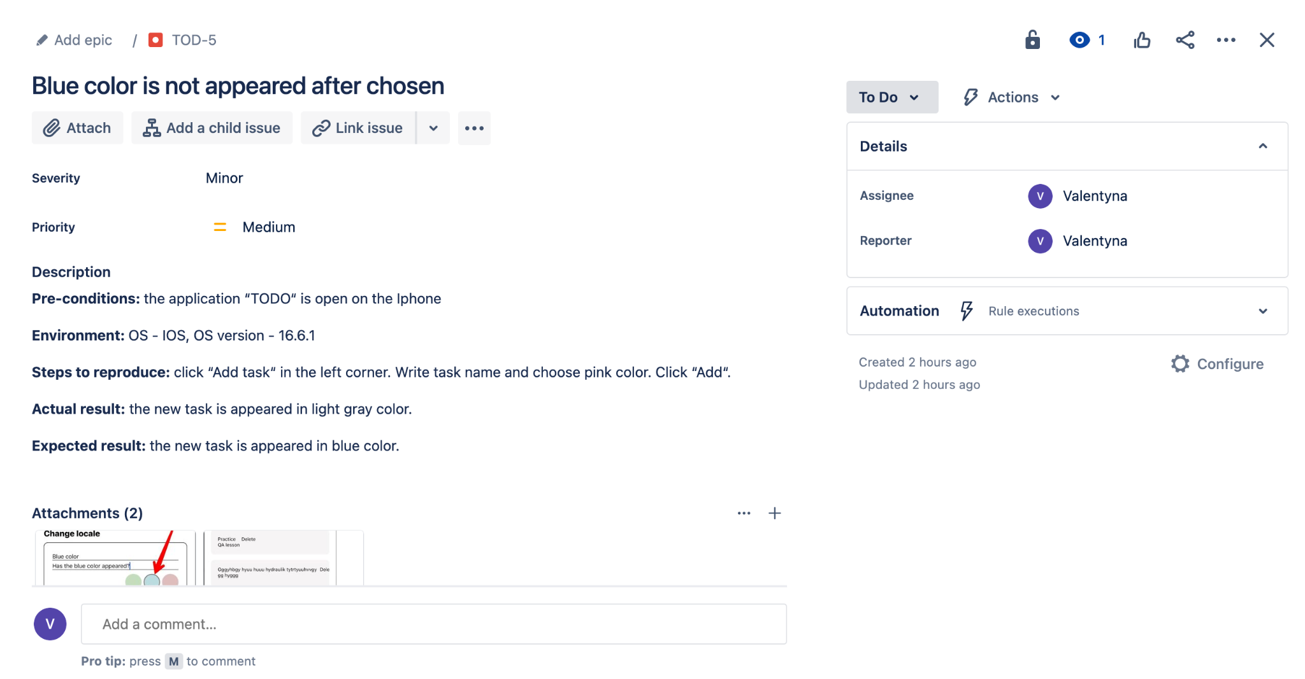

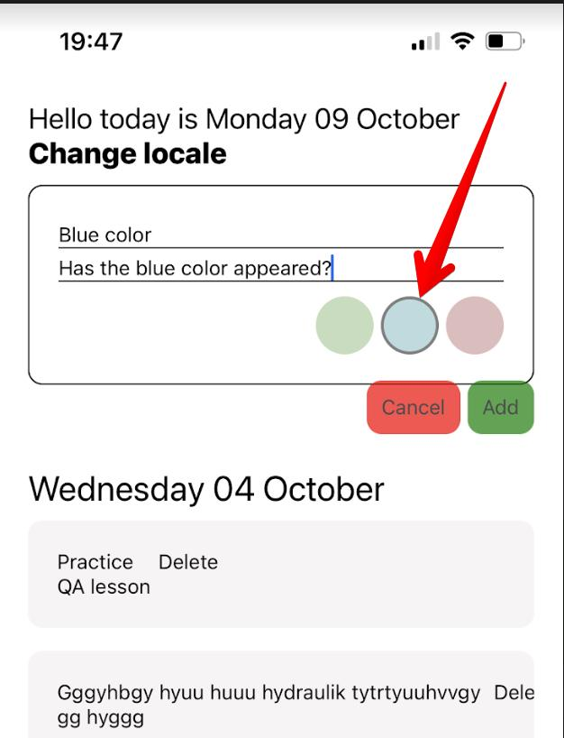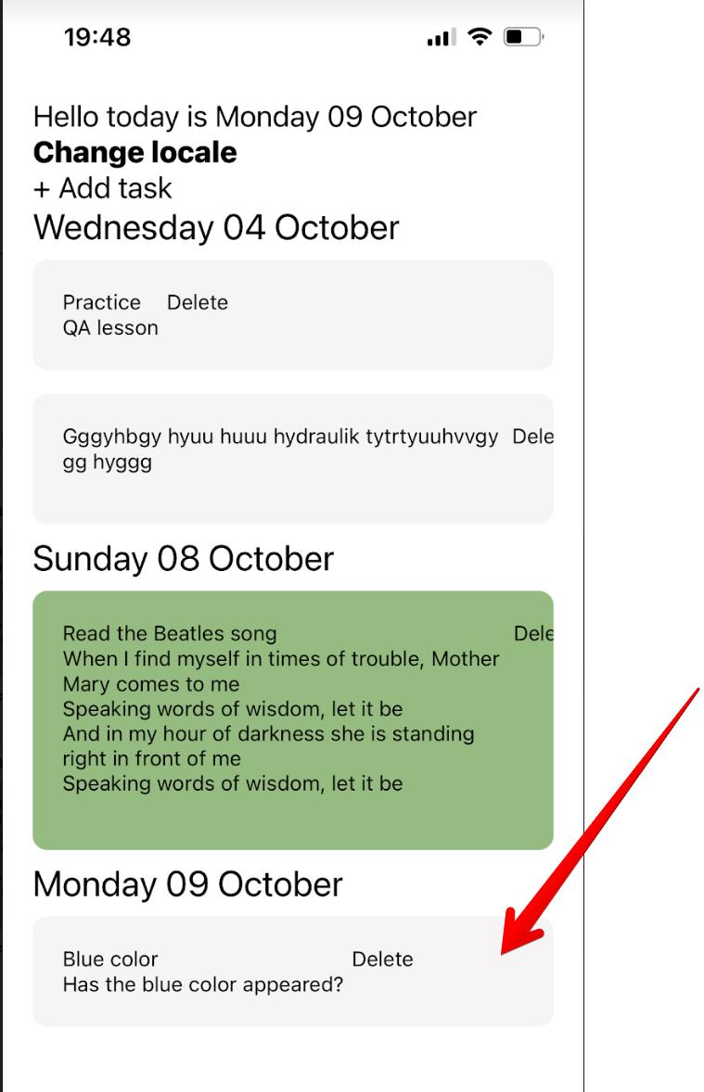

Bug 3

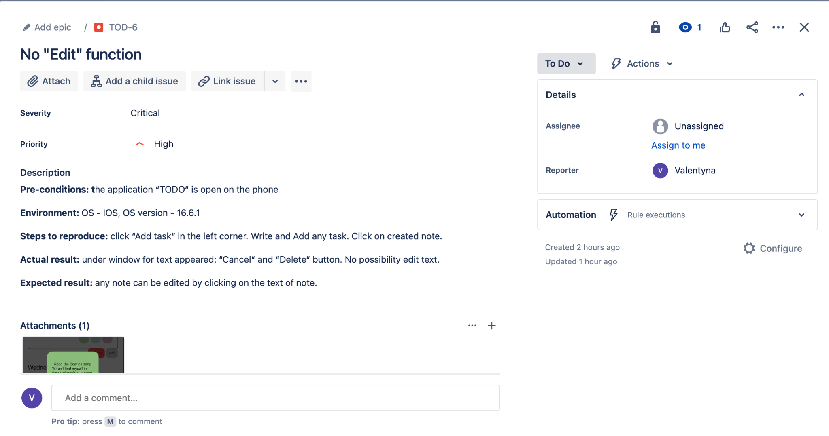

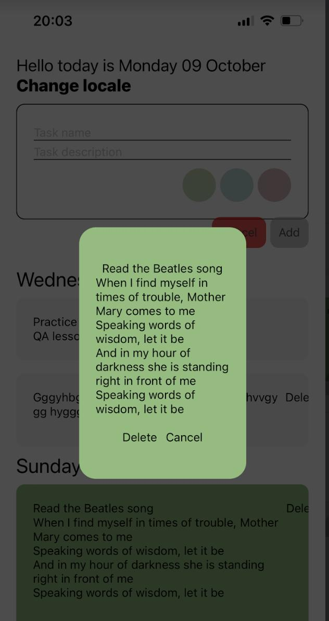

Bug 4

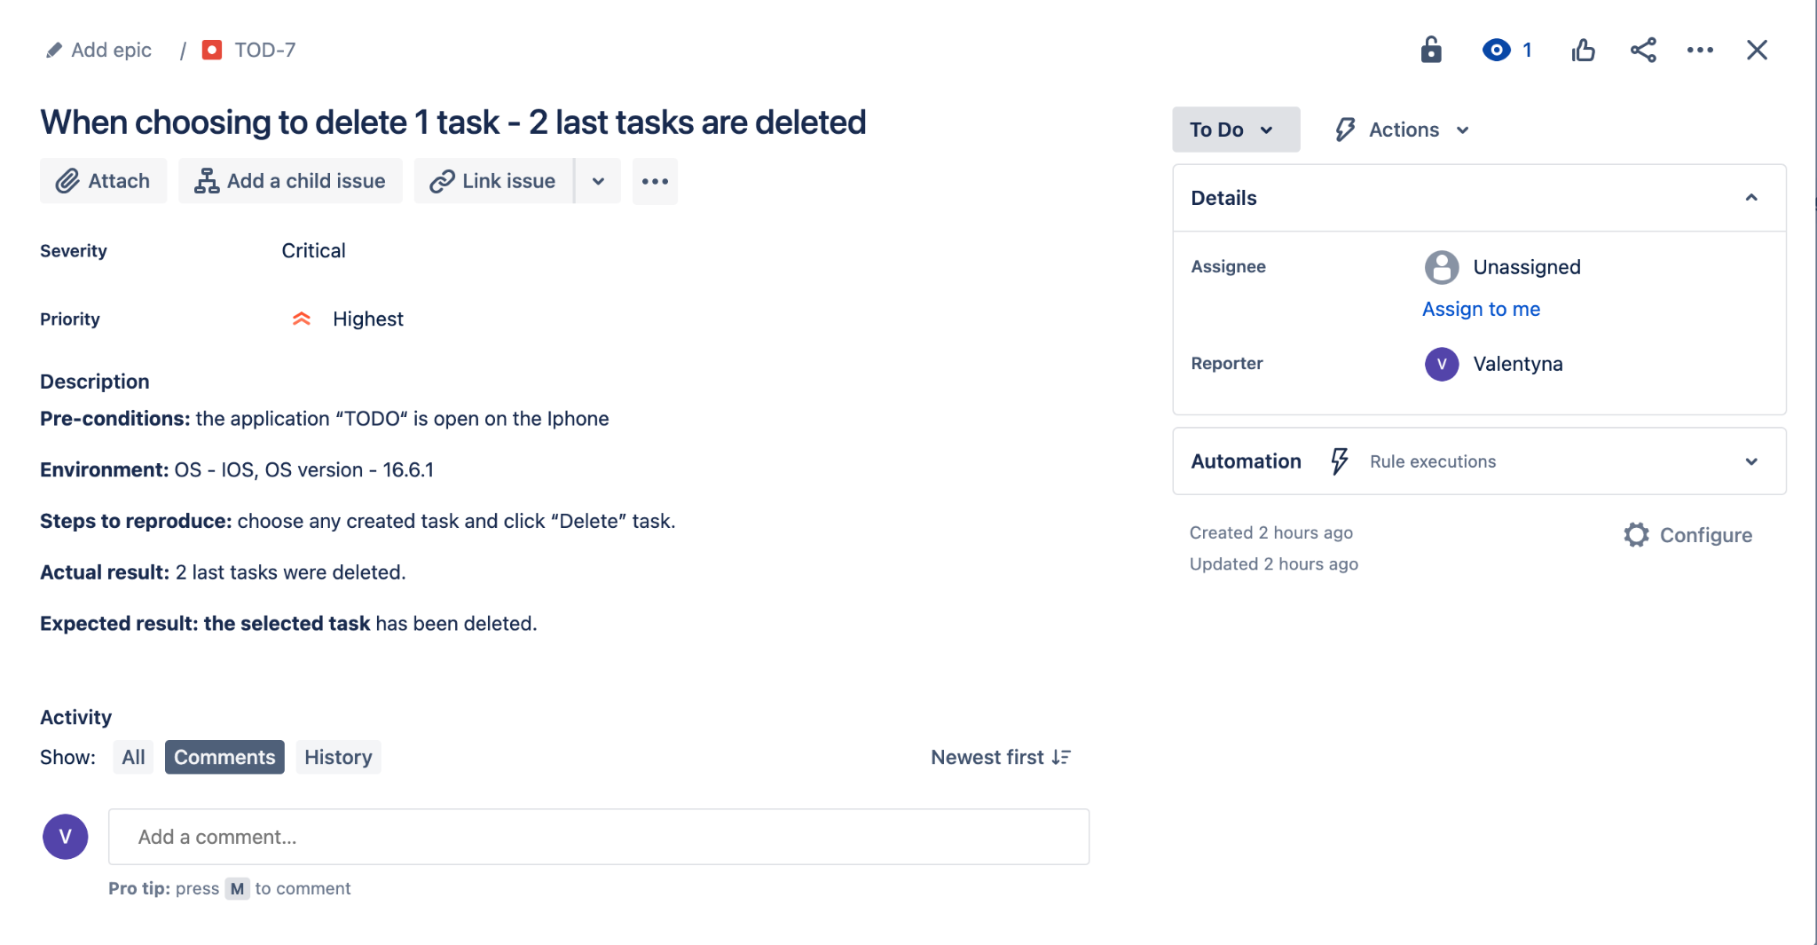

Bug 5

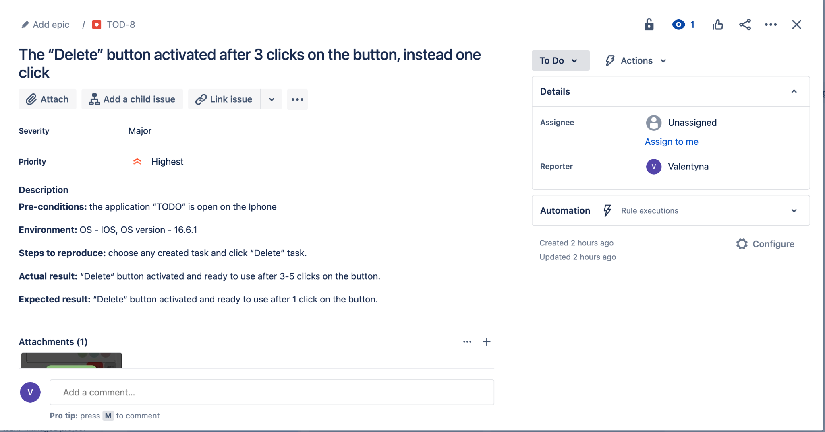

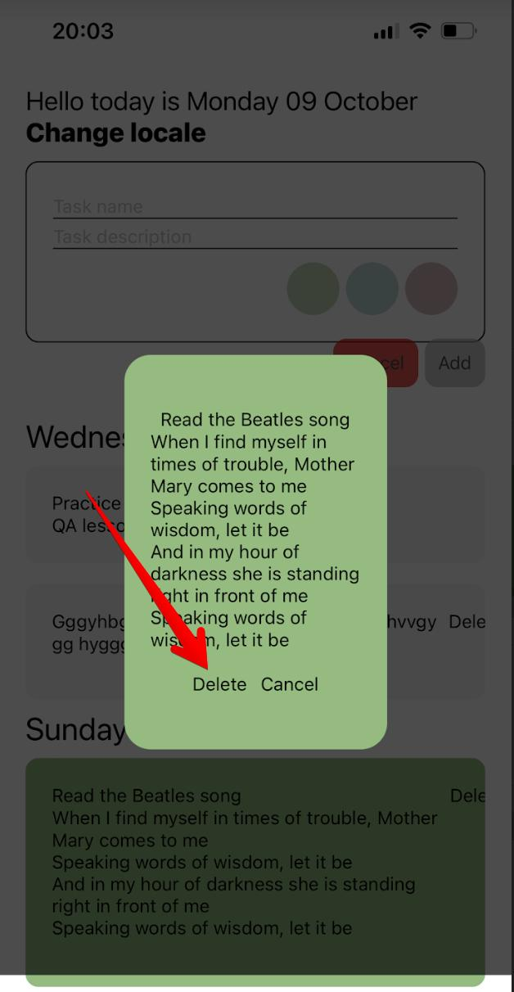

Bug 6

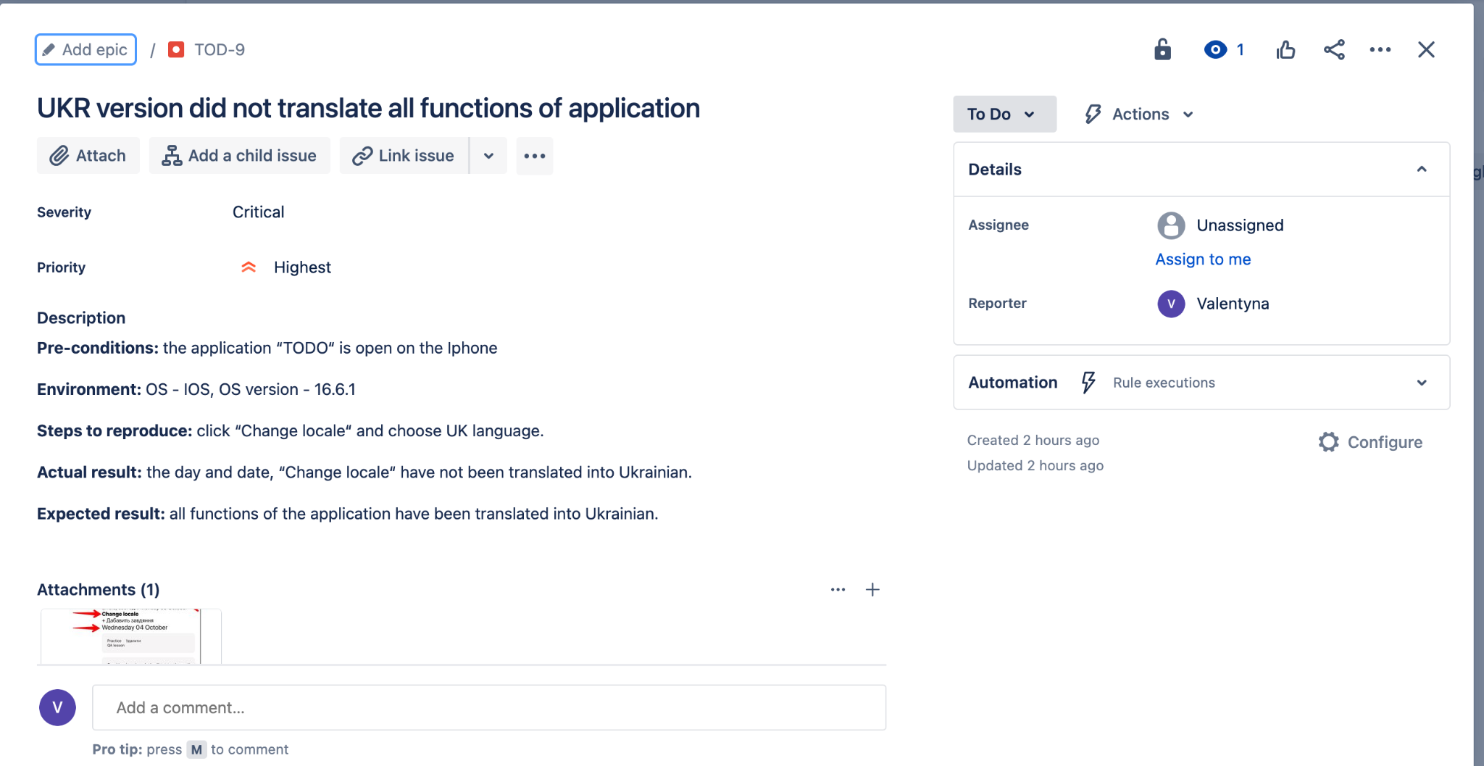

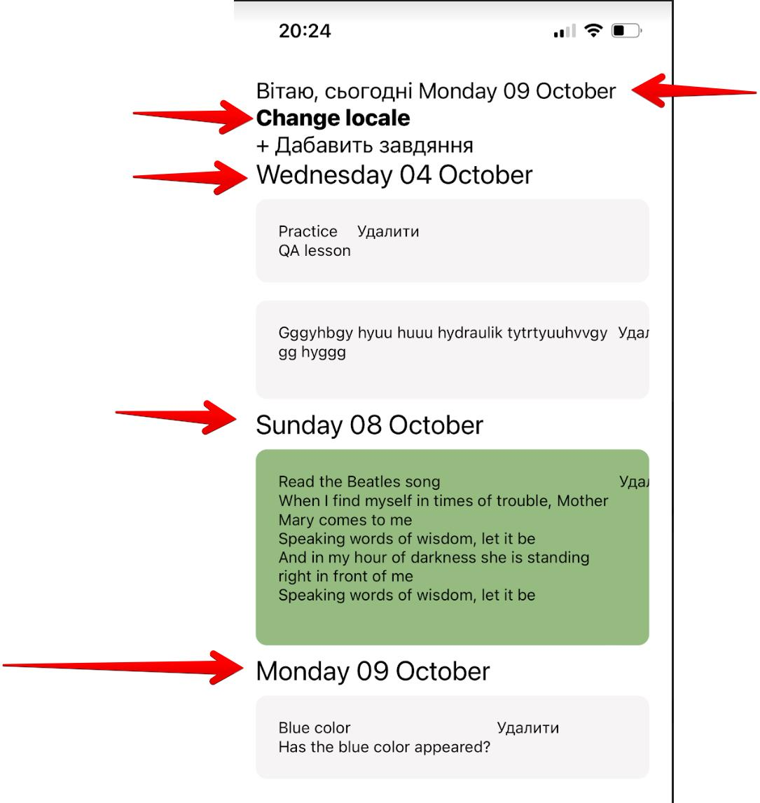

Bug 7

